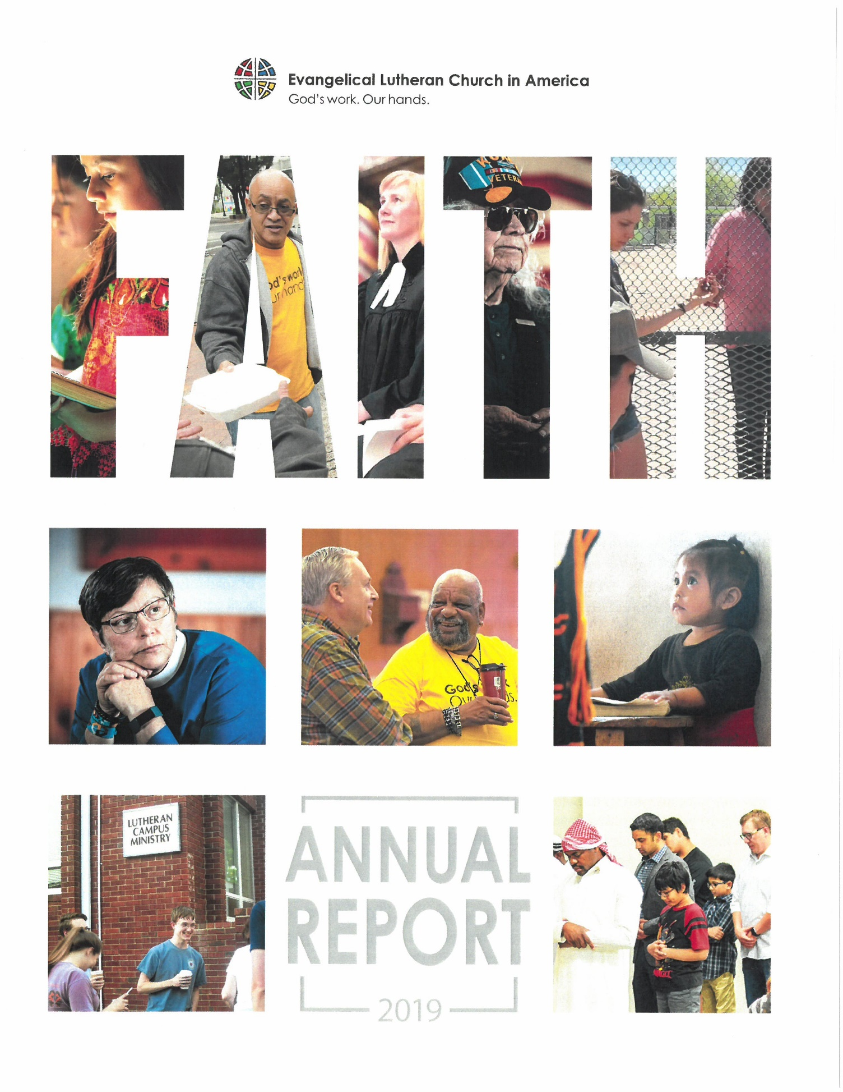

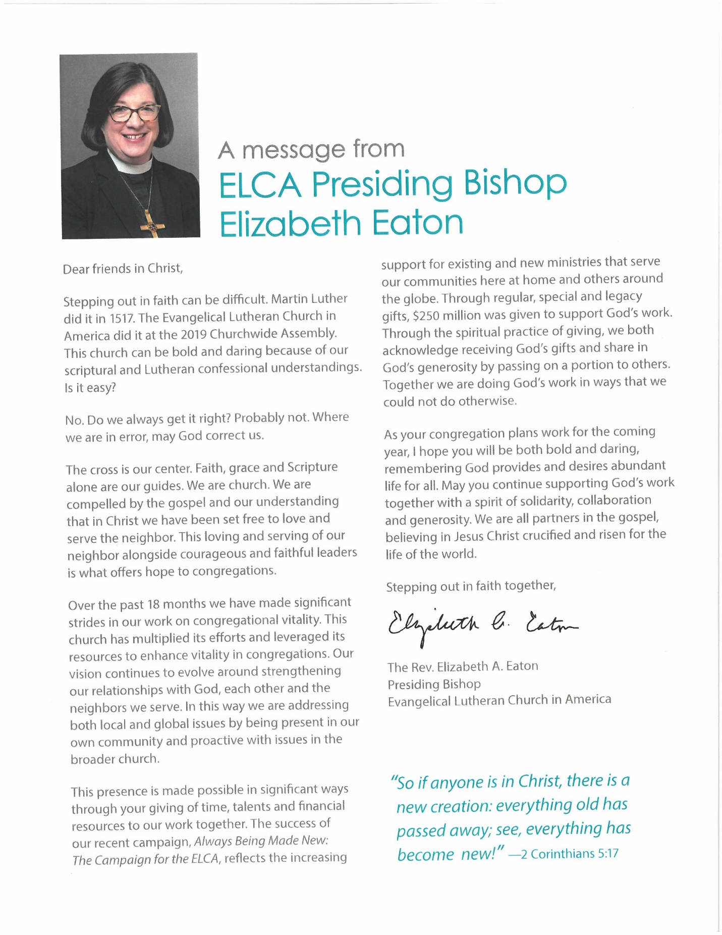

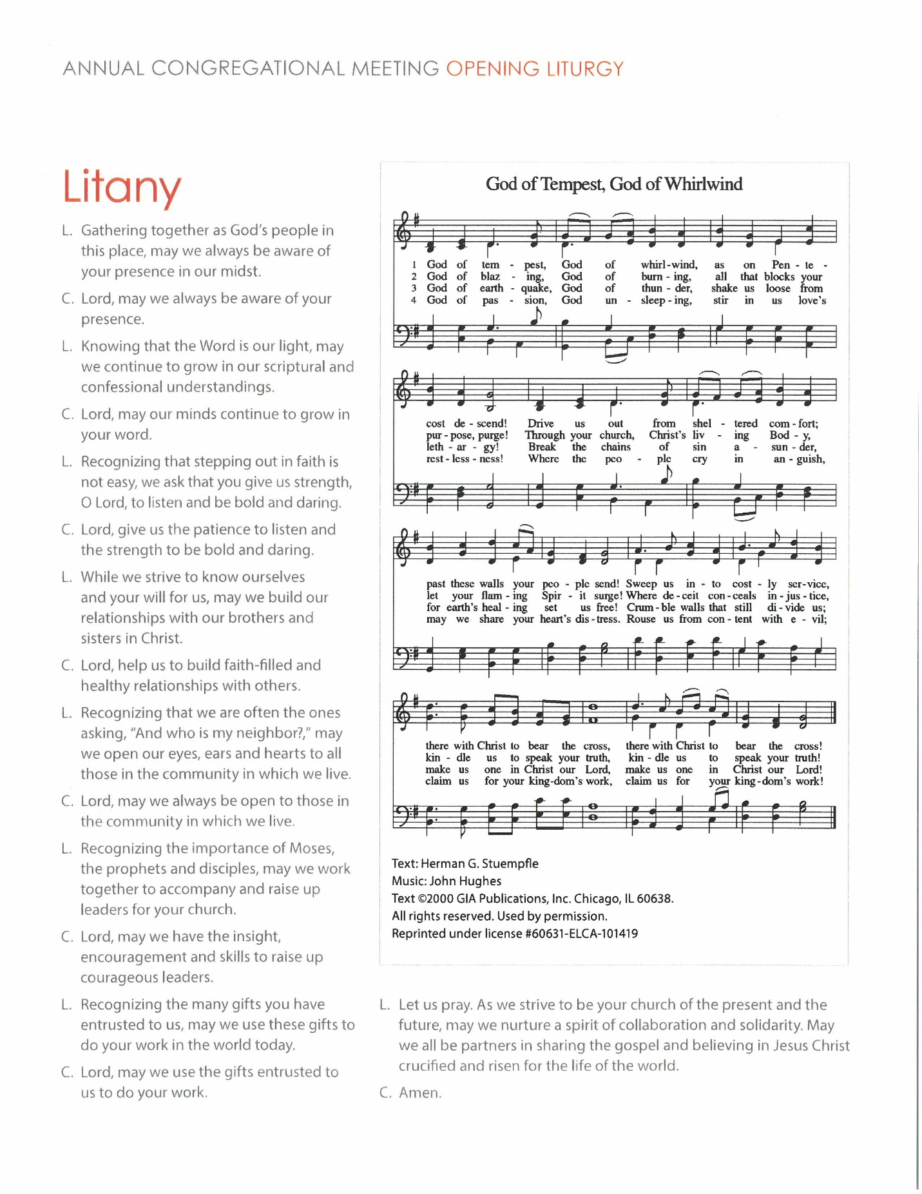

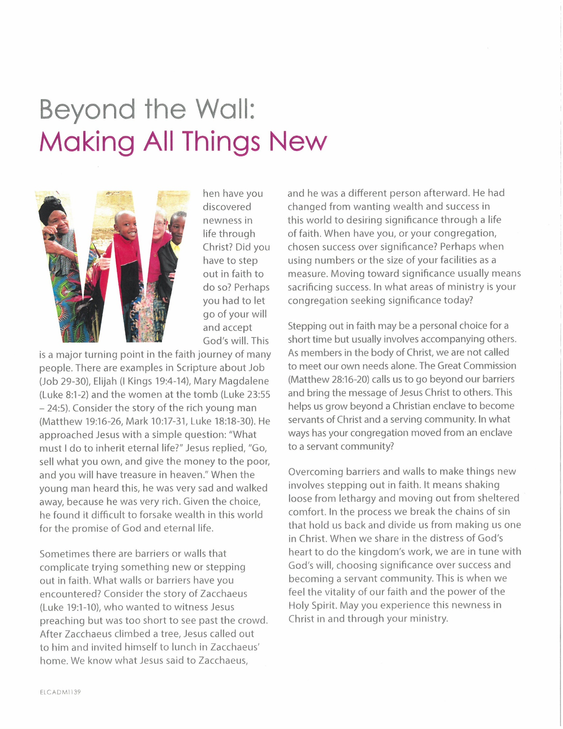

Trinity Lutheran Church
Annual Meeting of the Congregation February 9,2020

ANNUAL MEETING AGENDA 2
TRINITY LUTHERAN CHURCH COUNCIL 3
ANNUAL MEETING 3
COUNCIL PRESIDENT’S REPORT 4
Pastors’ Reports 5
Report of the Transition Consultant 5
Parish Administrator’s Report 6
Financial Secretary’s Report 7
FINANCE COMMITTEE REPORT 8
Mission Endowment Committee 2019 8
Thrivent Report 2019 9
Stewardship Report 10
SOCIAL CONCERNS TEAM 10
CALL COMMITTEE 12
Children & Youth Ministry Committee 13
Annual Meeting Report 13
Children’s Choir Community 16
W.E.L.C.A 17
AD HOC COMMITTEE REPORT 2019 17
TRINTY LUTHERAN CHURCH PET PANTRY 18
STEPHEN MINISTRY 2019 24
CHRIST CARING FOR PEOPLE THROUGH PEOPLE 24
Worship and Music Committee Annual Report 2019 25
Lutheran Campus Ministry 2019 Annual Report 26

ANNUAL MEETING AGENDA
Trinity Lutheran Church – 2019 Reports
February 9, 2020

- Call to order – President Jim Cooper
  - Opening Devotions – Pastor Michael Brecke
  - Approval of Minutes from February 10, 2019 Annual Meeting
  - Treasurer’s Report for 2019
- Elections
  - Nominating Committee Report
  - Nominations from the Floor (nominees must be present and accept)
  - Appointment of Tellers
  - Election of New Council Members
  - Election of Synod Assembly Voting Members
  - Election of Nominating Committee members
  - Election of Endowment Committee members
  - Vote on amendment of Bylaws & Constitution
- Reports
  - Pastor’s Report
B. Committee Reports
C. Organization Reports
- Amendments to Constitution & Bylaws
A. Model Constitution for Congregations approved by churchwide assembly
B. Council-proposed amendments
- 2020 Budget – Dan Warren, treasurer
- Report of Tellers
- Closing Devotions – Pastor Michael Brecke
- Adjournment

Rules and Procedures:
- The constitution requires a quorum of fifty (50) voting members.
- A voting member is defined as a confirmed member who has both communed and contributed since February 1, 2018. Voting members have voice and vote; vote by proxy is not allowed.
- Resolutions presented by the Congregation Council stand as motions before the house.
- Nominations for office may be made from the floor by any voting member provided however, that the nominee (also a voting member) is present to accept.
- Election of Council Members shall be by written ballot.
- Resolutions will be acted upon by voice vote unless otherwise determined by the house.
- All items for consideration, including proposed amendments of the budget and other business considered by the meeting, must have been submitted to the church office at least two weeks’ prior to the annual meeting.
- Discussion shall be respectful of others and no longer than three (3) minutes per person per topic.
-2-

TRINITY LUTHERAN CHURCH COUNCIL

ANNUAL MEETING
February 10, 2019
- Call to Order and Prayer – Jacob Larson and Pr. Jessica

Jacob acknowledged Megan McCoy, the organist. Handouts are on each table. The Transition Timeline was given out. This timeline is an approximate. Trinity needs to begin with self reflection.

- Minutes from 2018 – Annielaurie Seifert moved to approve the Annual Minutes from 2018. Kelly Cooper seconded; motion passed.

3. Treasurer’s Report – Jim Cooper reported we had a great month in December! We’re actually $2,000 ahead of budget!
4. Nominating Committee – Jim Cooper announced some changes to the ballot. Under Council Members, we’re adding Ted Smith to the first blank for a three year term. The second blank remains blank. Under the Nominating group – add Annielaurie Seifert to the one-year term. The three-year term is blank. The Audit Committee is being changed to a one-year term instead of three. The Synod Assembly members are Dan and Jane Warren. Four Tellers were chosen to count votes – Leah Larson, Wally Brockhoff, Sarah Stirn and Bella Maletsky. Pr. Kerr advised out constitution says we must have five members to vote for Council. Treva De Leon volunteered to be added to the ballot under Council members. Leah Larson moved that we close nominations and vote. Carole Rehder seconded; motion passed. Each member running was asked to stand up to be introduced. Tellers collected all the ballots.
5. Pastors’ Reports – Pr. Lou spoke on the benefits to going to one service starting March 3, 2019. The service will be at 9:30 a.m. Sunday School will meet afterwards. Some groups will meet before.
6. A huge thanks and standing ovation was given for Jacob Larson’s service as Council President.
7. Tellers Report – all members on the ballot were elected. 62 members voted. Council Members are Jennifer Martello, Webb Hecker, and Lorin Maletsky (each have a 3-year term). Endowment Committee is Susan Hadl (3-year term), Harriet Shaffer (3-year term) and Susanne Shaw (2-year term). Nominating Committee; Tami McNemee (3-year term), Harriet Shaffer (3-year term) and Annielaurie Seifert (1-year term). Audit Committee is Deb Black, Joe Box, and Tim Mock (each for 1-year term). 2019 Synod Assembly members are Dan and Jane Warren.
8. Committee and Organization reports are available in the booklet for review.
9. 2019 Budget – Training of our Youth Leader, Justice Matters, and the parsonage were also discussed. Janet Ross was acknowledged for all her years of serving as Financial Secretary! Charles Baars moved to pass the budget. Carol Ann Salber seconded; motion passed.
10. Vitality Survey – Pr. Jessica advised the vitality survey results are available on the bulletin board. This is a work in progress.
11. Jim Cooper recognized the contribution made by Lenoir Ekdahl, and how much her donation has helped at Trinity; we still have quite a bit left over! In 2019, communication will be critical, and we all need to be mindful of this.
12. Ruth Sarna introduced Alexander Arnone, and announced that he was a new Eagle Scout!
13. Closing – Jacob Larson challenged each member to invite one person to Trinity in 2019. Pr. Lou gave the closing prayer.
14. Post meeting vote 2/18/19 for Election of Officers: Jim Cooper for President and Tami McNemee for Vice President. Voting via email: motion passed.

COUNCIL PRESIDENT’S REPORT
Brothers and Sisters in Christ,
Our congregation is strong, resilient and successful, and we face the next year, and the next decade, with confidence and unbounded potential.
We have flourished with the nurturing, guidance and assistance of a great pastoral transition support team. We have an energetic and theologically grounded team leading our Music programs. We have a Director of Children and Youth Ministry in place. Our administrative staff is working hard to support us all. Our congregation is full of talented folks, and our various ministries are buzzing. The Lord has blessed us with so many gifts – we are far more blessed than most Evangelical Lutheran congregations in Russia, for instance, congregations which survived with only lay leadership for over 70 years during the Soviet period, and which still survive and flourish today. We are in a good place.
The Call Committee has been formed and is off and running. The committee is working diligently through the process, and we need to be patient and trusting with them as they complete their preliminary research and planning. The process may take as long as a couple of years, or it may go more quickly, but regardless, we need to support the committee by giving them room to operate and assuring them that they have our complete trust and appreciation. The Lord will guide them in proceeding on the right path to find the right permanent pastor to guide us into the future.
I have enjoyed the past six years on Council, although my year as Vice President was a tough one – this last one was a whole lot easier. But despite our occasional trials and challenges, I know that we are stronger and more unified. I look forward to Tami taking the reins, and will continue to participate and support our congregation as we move forward. Thank you for your support.
In peace,
Jim Cooper

Pastors’ Reports
2019 Membership*
*Membership is defined in the Congregation Constitution & Bylaws Sec. C8.04.01
2019 Removed
Deceased | 7
Transfer | 3
Request
Other
2019 Total Removed | 10

2019 Received
Baptisms | 10
Affirmations of Baptism | 4
Transfer | 0
Other
Total Received | 14

Membership as of December 31, 2018 | 399
Net Change in Membership | 4
2019 Total Membership (including inactive members) | 403

Report of the Transition Consultant

I know that many people at Trinity have been wondering why this transition has been taking so long. One factor has been the circumstances of the former pastor’s leaving and the need to regroup from that experience. Another factor has been the challenge of preparing thoughtfully and thoroughly for the calling of new pastoral leadership. It’s really that simple.
Even though the length of this transition has been unsettling, the capable and caring presence of Pr. Lou Flessner, Pr. Jessica Derise, and Pr. Michael Brecke have helped to calm things considerably and to engender a sense of hope. During the summer, a Call Committee was selected by the Council and since then has taken on its responsibilities with energy and enthusiasm.
During 2019, I invited the Congregation Council to wrestle around a book entitled The Hidden Lives of Congregations: Discerning Church Dynamics by Israel Galindo. Among other insights, the author cites the notion of congregational lifespan, describing a series of stages from formation onward. It reminds me of the St. Louis Arch that rises from one leg to its apex, then descends again on the other leg. One of the later stages in the lifespan is the Maturity Stage, and I think his description sounds a lot like Trinity right now. For example, here are three trends that I’ve observed at Trinity that I think are cause for concern:

- A shifting of responsibility for the ministry of Trinity away from congregation members and onto paid staff members
- A reliance on wills and estates to pay for long-term maintenance on the building rather than on general budgetary funds
- A lack of year-round stewardship development and education, including planned giving

You might consider borrowing a copy of Galindo’s book from one of your Council members, or even buying one for yourself. It’s worth the read.
I have heard it said around the Trinity household that “All we need to do is call another pastor and everything will be fine”. I’m inclined to challenge that notion, along with “It’s all about the pastor and nothing else”. Instead, I would encourage you to look as hard at yourselves as you look at your call candidates and consider prayerfully how to partner with your new pastor in making the next chapter of Trinity’s life and ministry as fruitful as possible.

Respectfully submitted,
Rev. Michael Kerr +

Parish Administrator’s Report

Into my 20th year at Trinity…
A lot has changed in 19 years, but this last year and a half has been especially busy and full of new challenges. In March we added a new office assistant, Jacob Gasho, a University of Kansas graduate who works at Trinity from 9 a.m.-12 noon, Monday-Friday. First of all, welcome to Jacob, and thank you to all of those who volunteered in the office, especially Carol Ann Salber, Molly Olson-Kelly, and Harriet Shaffer. I very much appreciate all of their assistance and faithfulness in keeping the office running in the morning.
We finally have a new and better website! It was developed by Sanders Software which was able to restore many of the features of the more detailed website we had a few years ago. We look forward to adding more content to it in the next few months, and appreciate your patience as we find what’s needed.
If you haven’t already, please sign up for our weekly “enews.” The enews, besides our weekly Sunday bulletin insert and monthly newsletter, is a primary way to communicate with you. It’s also more immediate – important when we need to get the word out right away, like for cancellations or updates. Send your email address to llatchinson@tlclawrence.org, and I’ll add you to our contact list. Also check out our Facebook pages. We have three: Trinity Lutheran Church, Trinity Lutheran Church Social Concerns, and Trinity Lutheran Church Pet Pantry. Again, these internet options allow us to provide more immediate updates and extra information, plus often photos! And if you are at a church event, remember to snap some photos – doesn’t have to be with great equipment as most phones take nice pictures. Then email them to me so I can add to our stock.
If you have any questions about scheduling, communications, committee/ministry budgets and expenses, want to volunteer or need to know who is in charge of a certain ministry, let me know, and I’ll help you find out.

Yours in service,

LaDonna L. Atchinson

Financial Secretary’s Report
Despite many challenges/changes this past year the members of Trinity Lutheran Church continue to support the church with their tithes and offerings. Total pledge cards received this year were the same as last year (66 households) but the amount that was pledged for 2020 increased slightly from $259,902 to $261,208.
Church members increasingly turn to our online giving program, Vanco Payment Solutions, as an available option for regular or one time giving. In 2019 26 TLC members used VANCO. Online donations are really quite easy and there is more than one option available. All you need to do is go to the church website, tlclawrence.org and press the “Donate Now” button. There you will be shown a number of different choices. You can set up a regular payment (weekly or monthly) or a one time payment from all major credit cards, bank debit card or your savings/checking account. It is important to note that TLC absorbs the cost of using your credit card or any banking fees. All VANCO payments are credited towards your pledge.
In March, 2019, Trinity Lutheran again successfully completed the annual validation for compliance with the requirements of the Payment Card Industry Data Security Standard and received a Certificate of Validation thanks to Janet Ross who completed the forms. The benefits of achieving PCI-DSS Compliance helps TLC take a proactive approach to data security and employee awareness relating to the acceptance and safe handling of credit card and bank payments. This certification greatly reduces the potential of a data breach or compromise to Trinity’s electronic fund giving.
Trinity also received donations/offerings in a variety of forms and for a variety of ministries. Some people sold stock and donated the proceeds and some people designated a portion of their RMDs. While the “general offerings” that are given through pledges, envelopes and loose offering cover operational expenses of the church, a number of ministries are also supported by member giving – Pet Pantry, Memorials, LINK, holiday funds, special events.
It appears that giving overall is down this year by about 10%. Envelope loose offering (offering that is not designated for any specific ministry) for the past five years:
2015 2016 2017 2018 2019
$ 320,959 | $ 377,323 | $ 417,014 | $ 389,600 | $ 350,219
There are five counting teams that volunteer their time to count the church offerings each week. Counters include Barb Bishop, Deb Black, Dwight Brinkley, Alita Cooper, Anna Hecker, Barb Kurtz, Sue Reeder, Carole Rehder, and Janet Ross. A new team of Rick Ehret, Deb Boatright and Sandy Hull are joining us this year as we say goodbye to counters Harriet Shaffer, Diane Mosher and Susanne Shaw. A huge thanks to all of these volunteers.
My highest priority is safeguarding your private information and my goal is to supply the Finance Committee, Church Council and Bookkeepers with timely and useful information about the income of the church. I am always available to discuss giving options, questions about pledges, pro’s and con’s of envelope giving, how to use VANCO, and any other questions you might have about the income side of the church operations.
Respectfully submitted,
Jane Warren

FINANCE COMMITTEE REPORT

Active members of the Finance Committee are: Tim Mock, Joe Box, Jim Cooper (chair), Harriet Schaffer, Jane Warren (Financial Secretary), LaDonna Atchinson (Parish Administrator), Dan Warren (Treasurer), and Pastor Brecke (ex officio).
The Finance Committee normally meets on the third Monday evening of every month and the first order of business is reviewing the financial report from the previous month. The committee then addresses any pressing financial matters. Several issues that the committee recommended to Council this year: changing Trinity’s banking accounts from Truity Credit Union to Intrust Bank; changing our financials from Glass Accounting to BE Bookkeepers; receiving the audit committee report and instituting changes; and managing the process to rent out the parsonage.
Finance considered emergent requests for funds not already budgeted for the year and coordinated with Mission Endowment and Memorial Committees to identify sources of funding, and then recommends solutions to Council. Finance also recommends to Council how to utilize Special Offerings and any other matters related to church finances.
Dan Warren is replacing me as chair of this committee with the New Year, and I am pleased that he has decided to do so. Best of luck to him in his new duties!
In God’s Peace,
Jim Cooper, Finance Chairman

Mission Endowment Committee 2019

The Trinity Mission Endowment Committee is responsible for overseeing two separate endowed funds of the church. Endowment Pooled Trust I, governed by bylaws protecting the principal, provides interest quarterly which feeds into a Mission Investment Fund account. The balance in this fund as of 9/30/2019 was $256,778.40. Committees and groups within the church may apply for funding which meets the criteria of the bylaws, primarily in advancing the MISSION of the church locally and throughout the community ands world. Members may contribute to the principal of this fund at any time. In 2019, one dedicated member donated $40,000 to this fund. Thank you.
Endowment Pooled Trust Fund II contains endowments from specific deceased members of the congregation (Milliken, Baker, Thompson) as well as unendowed funds from the Clepper estate invested there by the Church Council in 2012. Interest from the endowed funds goes to specific funds of the church quarterly (based on donor’s request) as follows: Milliken to Property; Endacott and Baker to Youth; Endacott to Music; Thompson to Council. Interest from the Clepper fund goes into Tech Reserves, Children’s Reserves, and Building Reserves funds. The balance in Pooled Trust Fund II as of 9/30/2019 was $375,480.41.
The Mission Endowment Committee met several times in 2019. The balance in the Mission Investment Fund account (into which interest from Pooled Trust Fund I is deposited quarterly) as of 12/31/19 was $9,411.06. During 2019, allocations were made to the following groups or committees of the church: Stephen Ministry, $1000 for training; Property for audio system updates from MSM, $2889; Youth for Trip and Youth needs, $1434; Property for painting Bethany House exterior, $1500; Central States Synod, Companion Synod, $1400; Pet Food Pantry for containers for storage outside of fellowship hall, $815; and Lutheran Campus Ministry, toward a staff position for future planning and fund raising, $5000.
These allocations met the bylaws requirements of a minimum of @0% toward social services; a minimum of 20% for the Mission of the ELCA in this continent and worldwide; a minimum of 20% for capital improvements, debt reduction, education, or building program of TLC, and up to $0% for OTHER, consistent with the Mission outreach of TLC. We have a funding application form which we send out at least three times a year to all committees and other groups in the church, inviting their requests for funding which meets the criteria of the bylaws.
Thank you to the members of the Mission Endowment Committee: Susan Hadl, Susanne Shaw, Annielaurie Seifert, Wally Brockhoff, and Harriet Shaffer (Chairperson). Thank you also to LaDonna Atchinson, Parish Administrator, for her assistance in many, many ways.
Harriet Shaffer

Thrivent Report 2019

PLEASE DON’T OVERLOOK THE POWER OF THE THRIVENT ACTION TEAM FUNDING. As a Thrivent member, you can obtain two debit cards a year ($250 each, for a total of $500) to help your favorite nonprofit agency with a fundraiser, an educational event, or a service project. We are NOT taking full advantage of this funding mechanism. This year Trinity members used Thrivent cards for expenses for fundraisers for the Corn Fest and for the WELCA Book, Bake, Bloom Sale. Another member obtained a card for a service project of the Confirmation Class at Christmas when they shopped for needy families and wrapped the gifts. Please see me if you need assistance in applying for a card. This is a terrific program and each Thrivent member can direct $500 a year to worthy projects.

Thrivent members at Trinity donated about $800 in Thrivent Choice Dollars in 2019. Deb Boatright and Harriet Shaffer as Congregational Advocates authorized expenditures – primarily to the Christmas Potluck and another social event. You will receive notifications from Thrivent if you are eligible to direct Thrivent Choice Dollars. Thank you to those members who continue to donate through Thrivent Choice to this congregation.

Stewardship Report
The theme of this year’s stewardship campaign was “The world of the generous gets larger and larger . . . the one who blesses others is abundantly blessed.” Proverbs 11:24-25.
Jennifer Alderdice presented a Children’s Sermon and created a table display in the Narthex around this theme. Temple talks were given before services in the month of October by Jacob Larson, Molly Olson-Kelly, Cathy Box and Steve Ozark.
Pledge cards and a stewardship letter were sent the third week of October and pledge cards that were returned by November 10, 2019, were blessed during the regular church service.
At this time last year we had 66 returned pledge cards for a total of $254,441 pledged. Again, this year we had 66 returned pledge cards for a total of $261,208 pledged.
A huge thank you goes out to volunteers Jennifer, Jacob, Molly, Cathy and Steve.

Respectfully submitted,
Dan Warren, TLC Treasurer and Stewardship Chairman

SOCIAL CONCERNS TEAM
‘Truly, I say to you, as you did it to one of the least of these my brothers, you did it to me.’ Matthew 25:40

During 2019, members of Trinity Lutheran Church continued to work in service to our neighbors in Lawrence.
Justice Matters: Trinity members participated in Justice Matters, an interfaith organization dedicated to working toward systemic justice in our community by: (1) collectively listening to the concerns and vision for our city among its many residents, (2) voting to select priorities, (3) researching the underlying problems we face and solutions that work, (4) creating the public will to improve our city at system-wide levels through the power of organized people, and (5) monitoring results to ensure the improvements are realized. During 2018-2019, Steve Ozark, Brian Elster, Chelsey and Jacob Larson, Keela and John Meiers served as our representatives. In 2019-2020, our representatives are Steve Ozark, Chelsey Larson, Kevin Boatright, and Alita Cooper. Trinity members were part of the community attending the Nehemiah Assembly on April 10, 2019. In 2019, Justice Matters led the community to raise its voice in favor of criminal justice reform; establishing and supporting the Affordable Housing Administration Board; and expanding the use of restorative justice within the Lawrence Public Schools. More than 20 Trinity members participated in the Problems Assembly on November 11.In 2020, addressing homelessness within our community was chosen as a new goal while continuing its advocacy for restorative justice in our schools and jail alternatives in the community.

LINK (Lawrence Interdenominational Nutrition Kitchen): We host LINK on the second Tuesday of every odd-numbered month. Approximately 100 meals are served. Thank you to LaDonna for helping publicize our service. Thank you to the many donors of food and money. A big thanks to the volunteers who shop, transport food, serve, and clean-up. A special thank you to Carole Rehder who is the Trinity coordinator.

Habitat for Humanity: Trinity gave a contribution of $1500 to the Faith Build in 2019. Our future participation of H4H is still to be determined as they add programs such as Aging in Place. We are currently in need of a liaison to the H4H board.

Trinity Episcopal Food Bank: We continued to collect and deliver food to the food bank. Thank you to LaDonna, for her regular updates on needs at the pantry. Thank you to Barb Kurtz and others for delivering food to the pantry.

Salvation Army Kettle Collection and Thanksgiving baskets: Trinity provided one evening of volunteers to ring bells at the Dillon’s Store at Lawrence and 6th Street. The weather was lovely (especially compared to the previous year) and the volunteers had a good time. Customers were generous. As a congregation we also contributed $125 to the Salvation Army’s annual Thanksgiving baskets.

New York Elementary School Supplies: We held a successful school supply collection. We delivered these to New York at the beginning of the school year. We also provide clothing and supply needs to individual students in need who are referred by the school social worker. These items are funded through monetary gifts to the school supply collection.

Family Promise: Trinity served as a support congregation to host church First Southern Baptist. During quarterly hosting weeks, we provided 3 nights of dinners and hosts, as well as snack/breakfast/lunch items for the guests. Thank you to all of our food providers and hosts, especially the faithful corps who volunteer almost every time we need them! We invite others to join us. This is a really joyful ministry. Our host weeks in 2020 are March 15-22; June 21-28; September 13-20; December 13-20.

Trinity Social Concerns Team
Deb Boatright, Chairperson
Steve Ozark
Keela Meiers
Carole Rehder

We welcome new members to join us, as we help minister to those in need in our local community!

CALL COMMITTEE

The Church Council oversaw a process to appoint the Call Committee to guide our journey to call a pastor. The following people serve in this capacity and always welcome your reflections and questions:
Beth Llewellyn: bethllewellyn55@gmail.com 402-630-7948
Charles Baars (alternate): chasbaars@gmail.com 785-331-7768
Wally Brockhoff: wbrockhoff@polsinelli.com 913-526-6749
Jeff Heline: jeff.heline@jostens.com 785-840-4264
Julie Holmberg (alternate): 785-843-4187
Oliva Rice: oliviaannrice23@gmail.com 785-766-4221
David Schwabauer: David@midwestsalesgroup.com 785-218-5222
Jarvis Stirn: wildhawk@hotmail.com 785-550-7179
Jane Warren: dcjgwarren@gmail.com 402-658-2951

At year’s end the committee is well into the initial phase of our process: listening across the breadth of our congregation to understand who we are and to what the Holy Spirit is calling us.
In the New Year we anticipate completion of the Ministry Site Profile by early March, the beginning of the Lenten season. This point will mark the beginning of the Synod’s work to put together a confidential list of candidates who are interested in our Trinity ministry based upon our MSP. During this phase we also welcome any suggested names of pastoral candidates of whom you may be aware. The Call Committee will provide those to the synod.
Our goal is to extend a call in the summer of 2020. Our prayer for this journey:
Dear Christ in this our Epiphany moment upon moments we place our petitions before you and ask-
Lord Jesus Christ open our eyes to the vision, the paradigm shift, you have for us in Christ, Come Holy Spirit
Lord Jesus Christ open our ears to the call you to have for each of us and us corporately as a community of faith, Come Holy Spirit
Lord Jesus Christ open our hearts to the needs of one another and the needs of your people who are silent, Come Holy Spirit
Lord Jesus Christ open our minds to deepen an understanding of the word you have given to us so that we may know your wisdom from above, find patience for this journey and confidence that you walk with us, Come Holy Spirit
We lift these our petitions to you Lord Jesus Christ on the eve of Epiphany, Come Holy Spirit. AMEN

Children & Youth Ministry Committee

Annual Meeting Report
February 2020

Greetings Council and Congregation:

Currently this committee is chaired by Terelle Mock with member Karen Nicholas. We would love a few more members on our committee. We look forward to a new council liaison being assigned. We have continued our past practice of meeting on an as needed basis. Our meetings are usually held in January, May, August and October.

We have once again had roller coaster of a year. We hired and lost our first Coordinator. We learned some lessons from this experience and hope to have more success in the future. In the meantime, KC Atchison has filled in on an interim basis assisting in keeping the nursery going and working on the youth service trip, we are thankful for her time.

Kelly Rice and Karen Nicholas will be receiving applications and conducting interviews for the coordinator position this spring. The goal is to have a Coordinator hired by May.

Programs Overview

K-5th grade: Leadership – Terelle Mock

At present we have 12 children attending Sunday School. Due to our small numbers and limited teachers we reduced from three to two classrooms. The First, Second and Third graders are combined with teachers Cassidy Krause and Lorin Maletsky. Fourth and Fifth grader are taught by Belinda Sturm and Anne Brockhoff. We do not have any kindergarten or pre-k children. Our numbers continue to be a concern. There are two 5th graders who regularly attend that will be moving up to confirmation next year, so the total number of children for next year will likely be 10.

Those that attend have had a great year! Maggie Werth has taken up the role of music director with enthusiasm, skill and lots of patience and we are very thankful!! We still begin our Sunday School hour with music and announcements. This year’s curriculum is Spirit and Truth: Teaching Kids the Heart of Worship. This is a curriculum previously purchased and used by the church several years ago. The curriculum teaches children the significance of the different parts of worship (confession, forgiveness, glory and praise, etc.) and the church year (Reformation, All Saints, Pentecost etc.).

We enjoyed our Christmas program again this year. Thank you to all who complimented, encouraged and thanked our children and teachers. The Christmas program is a highlight of the year.

Youth Activities – Karen Nicholas

The Trinity Lutheran youth have had an active year! The youth group (comprised of both the confirmation students and high school students) hosted a Halloween Party for the elementary Sunday School kids (and their families), shopped for Christmas gifts for an adopted family during the holidays, participated in a mission trip to Indianapolis and attended Camp Tomah Shinga.

The youth are in the midst of planning another mission trip for this summer, and several youth will attend Camp Tomah Shinga again this year. The Endowment Committee kindly fulfilled our financial request to update the youth room, so we hope to paint it this spring/summer.

Confirmation Update: Leadership – Karen Nicholas

Since I’ve been volunteering at Trinity Lutheran, this is the largest confirmation class we’ve ever had. We currently have 11 students, and they all attend weekly! Five of these students will be confirmed in the spring.

The Confirmation class curriculum follows a three-year cycle: Old Testament, New Testament and Catechism. We finished studying Catechism in May, and we started on our Old Testament curriculum in the fall. During the Lent season last year, we focused on doing acts of kindness for others including sending homemade birthday cards to fellow members, baking cookies for after service fellowship, and making an effort to do simple, nice gestures such as smiling at someone, holding the door for others or helping with chores at home.

As with years past, we’ve had wonderful participation and well-attended weekly classes. The weekly classes are taught by Milford Limesand and Karen Nicholas.

High School Update: Leadership – Jennifer Martello

Currently, there are thirteen high school aged students in the congregation. The 2019-2020 church educational year started with three high school students who committed to attend Bible study every other week. Molly Olson Kelly and Jennifer Martello taught the class. At the start of the school year, Jennifer contacted each family and high school student individually to inquire if they would be interested in attending Bible Study. Here is a summary of responses received:
- One parent stated they now attend a different church where the two teenagers are happy.
- Four teenagers stated they work on Sundays and therefore cannot attend Bible Study. When asked about an alternate time to meet, they were noncommittal.
- Two families/teenagers did not respond
- One family stated: “thank you for the reminder, but we have gotten out of the habit of attending church on Sunday mornings.”
- One teenager said: “Sure, I’ll come to Bible study”, but never did. His older sibling did not respond.
- One family responded their kids play sports on the weekend and they like to sleep in on Sunday mornings.

The Serendipity Bible is used for class curriculum. Students choose a weekly topic to discuss and study. KC Atchison researched some other programs/study courses the students expressed interest in doing, however, due to declining attendance, we decided not to invest in the new programs at this time.

Throughout the Fall semester, Bible study attendance was very sporadic and inconsistent. Class reminders were routinely sent via Group Chat, texts and emails. Jennifer Martello again reached out to each family and did not receive any new commitments to attend Bible Study. We decided to stop meeting on Sunday mornings due to student’s busy work and school commitments that take place on the weekends.

Some of the high school students have been able to attend the fun events Karen Nichols has planned this past semester. Currently, three high school students have committed to the mission trip this upcoming Summer. These three students have brainstormed Mission trip fund raising ideas, but due to the youth coordinator turn over and limited youth meeting time, these activities have been tabled.

On a personal note, even though the students have not been able to commit to bi-monthly Bible study on Sunday mornings at this time, over the past two years, I have seen friendships develop between the church students. Several of the students routinely get together for “hang out” time and are in constant contact through social media. It has been great to see this happen.

Items we need help with:

- Assistance in outreach. As stated above our Sunday School numbers are dwindling. Thankfully, most of the children reengage in confirmation, but we would like to see our Sunday School numbers grow.
- We are still looking for someone to fill the coordinator position. We have redirected our focus towards more of a grassroots approach rather than soliciting applications from online sites. Please spread the word amongst your social groups that we are looking and encourage all applications!

Thank you,
Children & Youth Ministry

Children’s Choir Community

I've been asked to spearhead the creation of a community children's choir, grades 3-5, which will meet at our church. Pastor Lou says, "making music together transforms the lives of young people, opening for them an expanded vision of beauty and goodness, integrating them into the rich tradition of Western music and introducing them to international music as well." I agree. The goals of our choir would be to serve the families of our community and to develop relationships in the community. Our choir would be affordable for all families, provide quality vocal training, with no auditions required. Providing transportation has even been discussed. As we don't see the choir beginning until next fall, it is still in its early formation stages, but we hope to have the choir perform at Trinity 3-4 times a year, and also sing in the community 3-4 times a year.

We are all aware of the amazing Lawrence Children's Choir in our community. They travel the world, perform at Carnegie Hall, have several graduated choirs, and have an international reputation. That will not be our choir. Our focus is on local performances and inclusivity, without regard to qualifications or fees.

We've established a gifted board of 9 members - 6 Trinity members and 3 community members - and we met once in the fall, so far. The board will govern the choir, create the program and strategic plan, draw up a budget, interpret its mission to the congregation and community, coordinate with the musical staff of local schools, and develop resources among members, residents, and businesses. The choir will be its own tax-exempt entity separate from Trinity Lutheran Church. Donations from Trinity members will be much appreciated, but we do not expect that our choir will be supported by Trinity Lutheran Church.

It is expected that the board meetings will now happen monthly as we gear up for the start of our choir next fall. We will keep you informed as our plans firm up over the next few months. Please contact me if you have any questions. And we would appreciate it if you keep us in your thoughts and prayers as we move forward!

Sandy Cooper

W.E.L.C.A

AD HOC COMMITTEE REPORT 2019

The Ad Hoc committee consisting of Cheryl Taylor, Karen Sanders, Sue Reeder and Carol Salber, meet in December to discuss suggestions for our end of year giving.

The suggested designees are:

- Lutheran World Relief 750.00 plus LC 22.02 thankoffering 5.00
- ELCA Women & Girls Support 750.00
- Lutheran Campus Ministry = local 750.00
- ELCA disaster fund 400.00
- Trinity Food Pantry 400.00
- Haskell Lite 400.00
- The Willows 400.00

Respectfully submitted,

Carol Salber, Treasurer

TRINTY LUTHERAN CHURCH PET PANTRY

Trinity Lutheran Church Pet Pantry (TLCPP) strengthened our mission in several ways this year. Thanks to the TLC Endowment Fund Committee, we were able to spay/neuter over 40 pets. Additionally, we vaccinated over 80 pets due to a Douglas County Foundation grant. Our distribution averages continue to be approximately 800 pounds of dry dog food each week and 300-400 pounds of dry cat food. Canned pet food, litter and snacks are all dependent upon donations. Most often, we have been able to provide at least some of everything. Rolling shelves (again, thanks to Endowment) now make set-up and take-down more manageable.
The Advisory Board has been busy forging relationships and identifying our desired policies and procedures. In the last year, we have communicated extensively and specifically with the Lawrence Humane Society, Great Plains SPCA and Sunflower Natural Pet Supplies. All have been benevolent to TLCPP and interested in uniting forces. Discussions are on-going as we combine efforts to accomplish more for the community.
Dr. Cathy King, DVM, has been a great asset. She has connected TLCPP with providers as we concentrate on issues of sustainability. Dr. King has also been instrumental in growing our pet wellbeing emphasis. Dr. King and Judy Culley (retired Executive Director of The Children’s Shelter) keep the Advisory Board thinking globally and in pursuit of local assets.
The TLCPP volunteer base remains both dedicated but in flux. A core group of folks step up every Friday and Saturday morning to provide stewardship for our pets and families. More help is always desired. Please call either Bruce and Joan Wohlers (785-221-1090) or Susan Hadl (785-764-8365) to find out how you can share your manpower.
Please see the attached graphs for information regarding 2019 statistics.

Respectfully submitted,

Susan Hadl

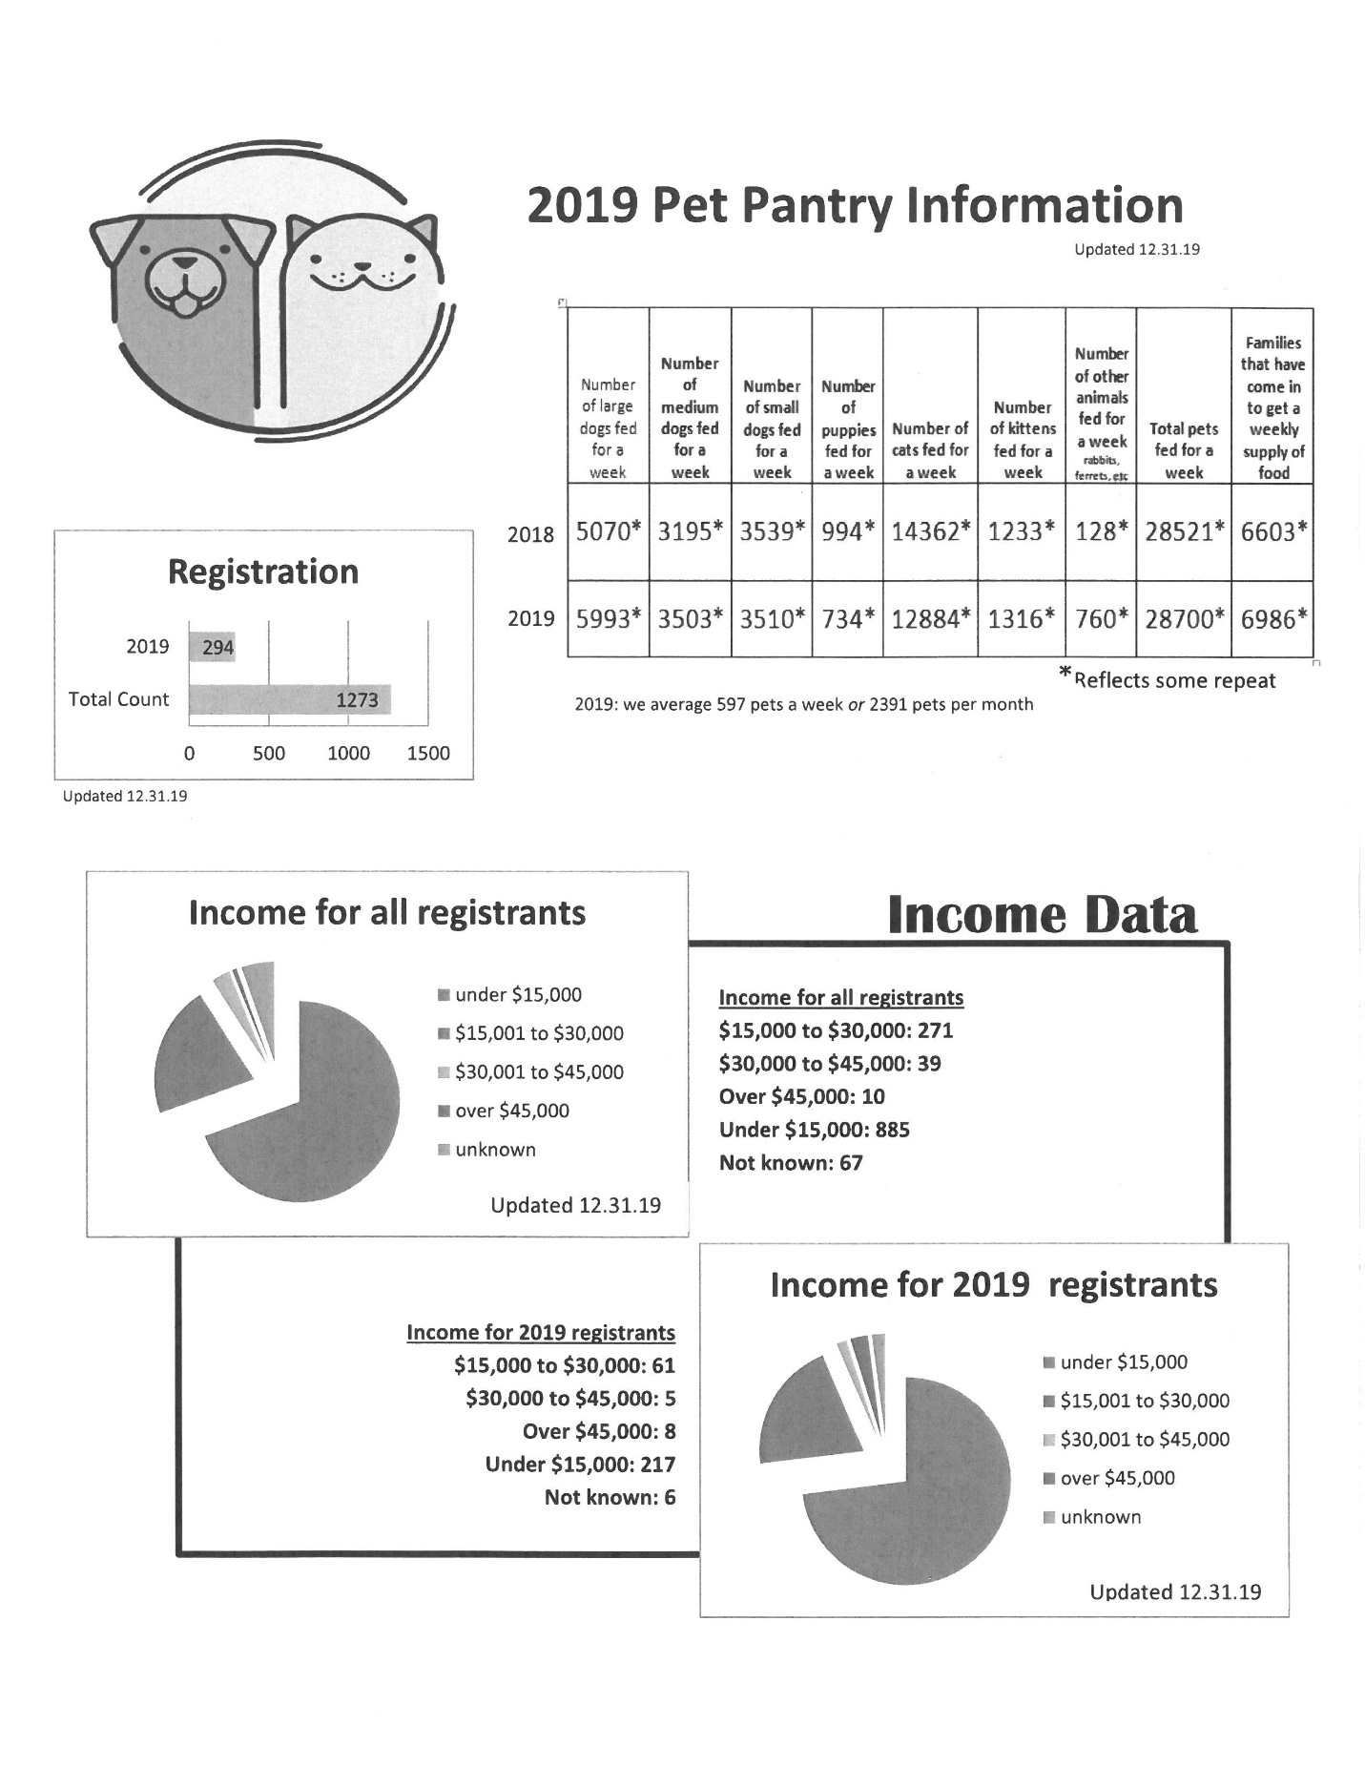
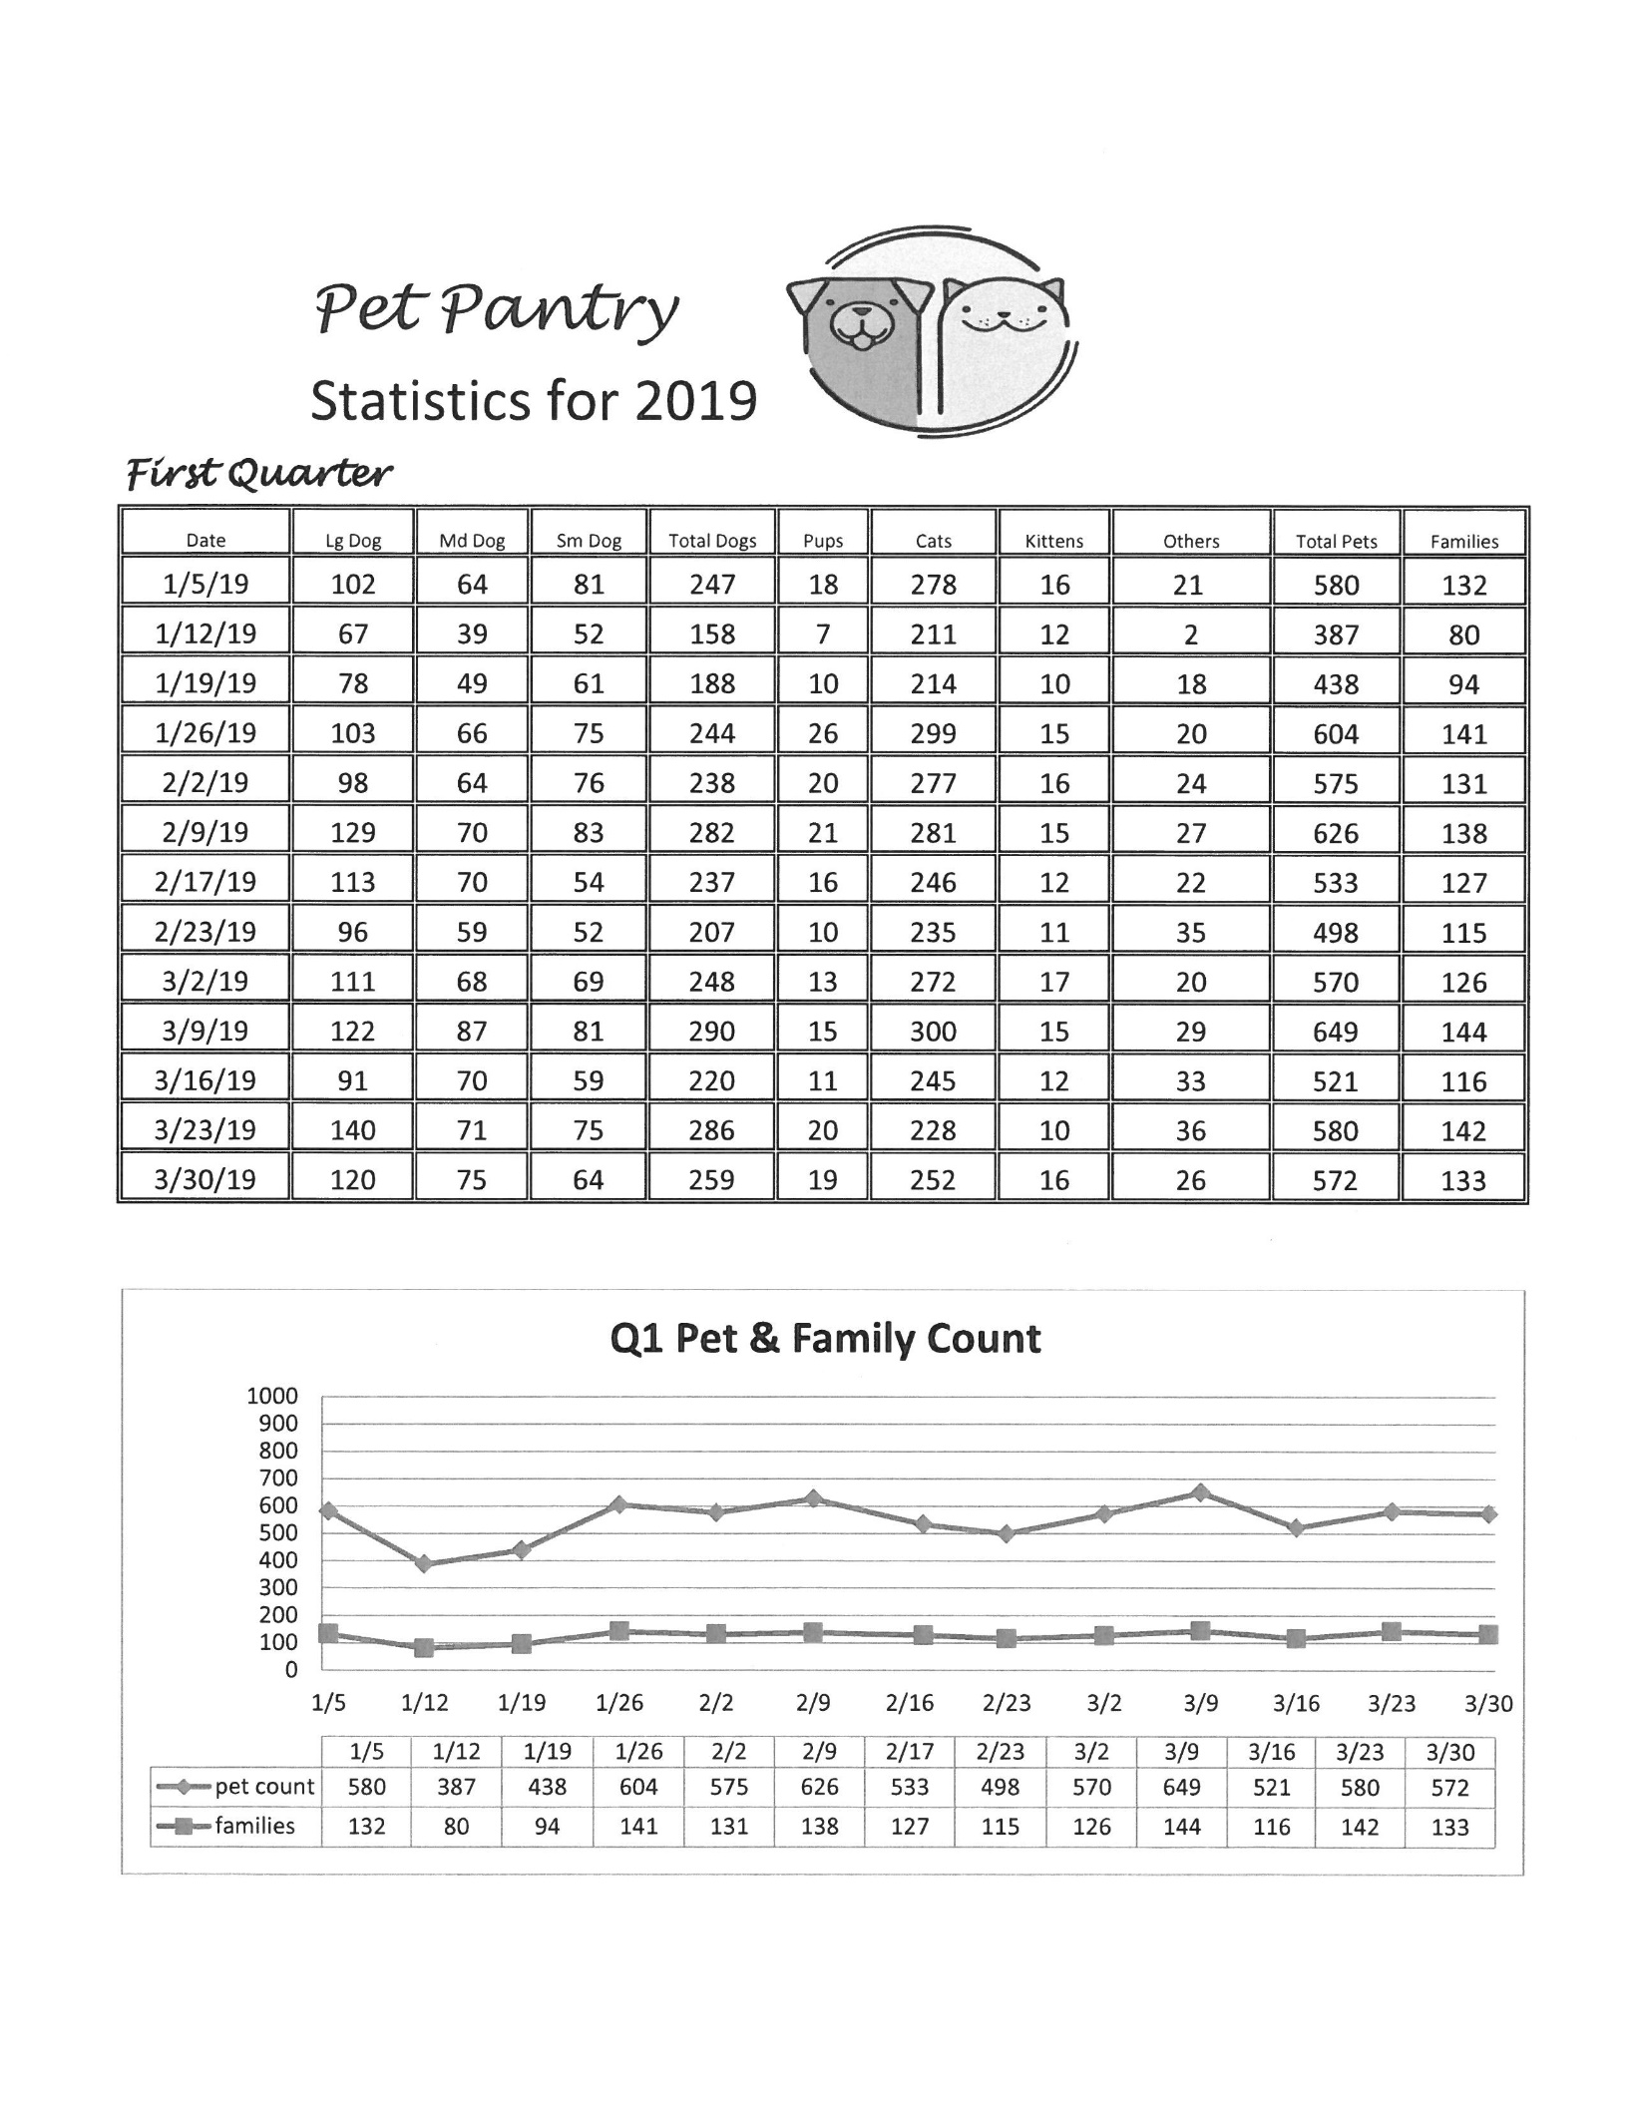

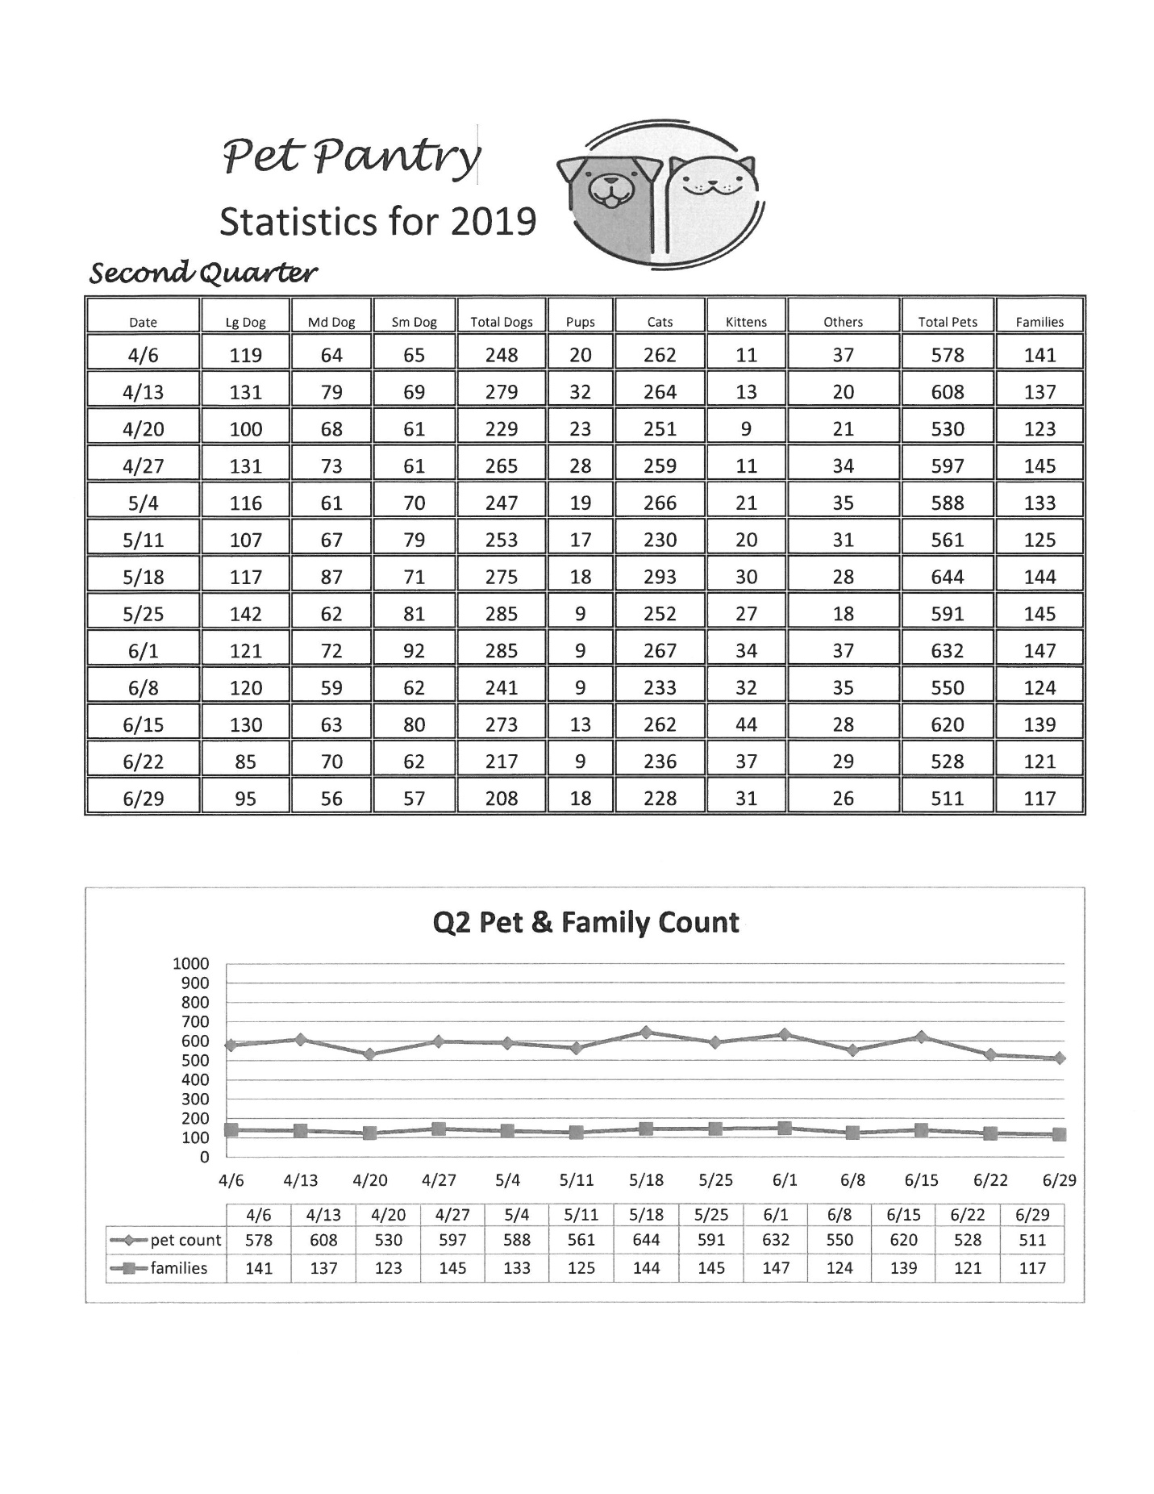

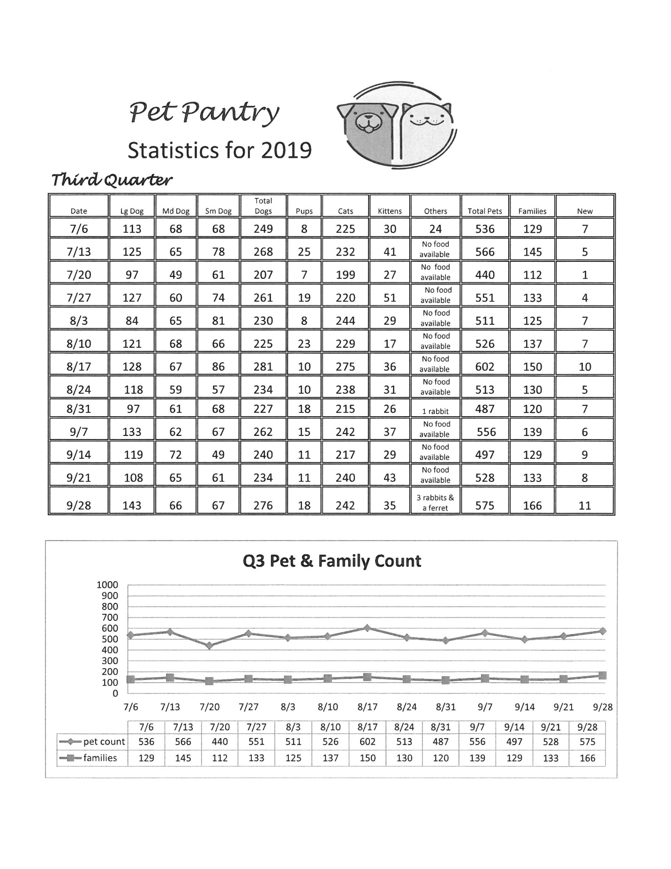

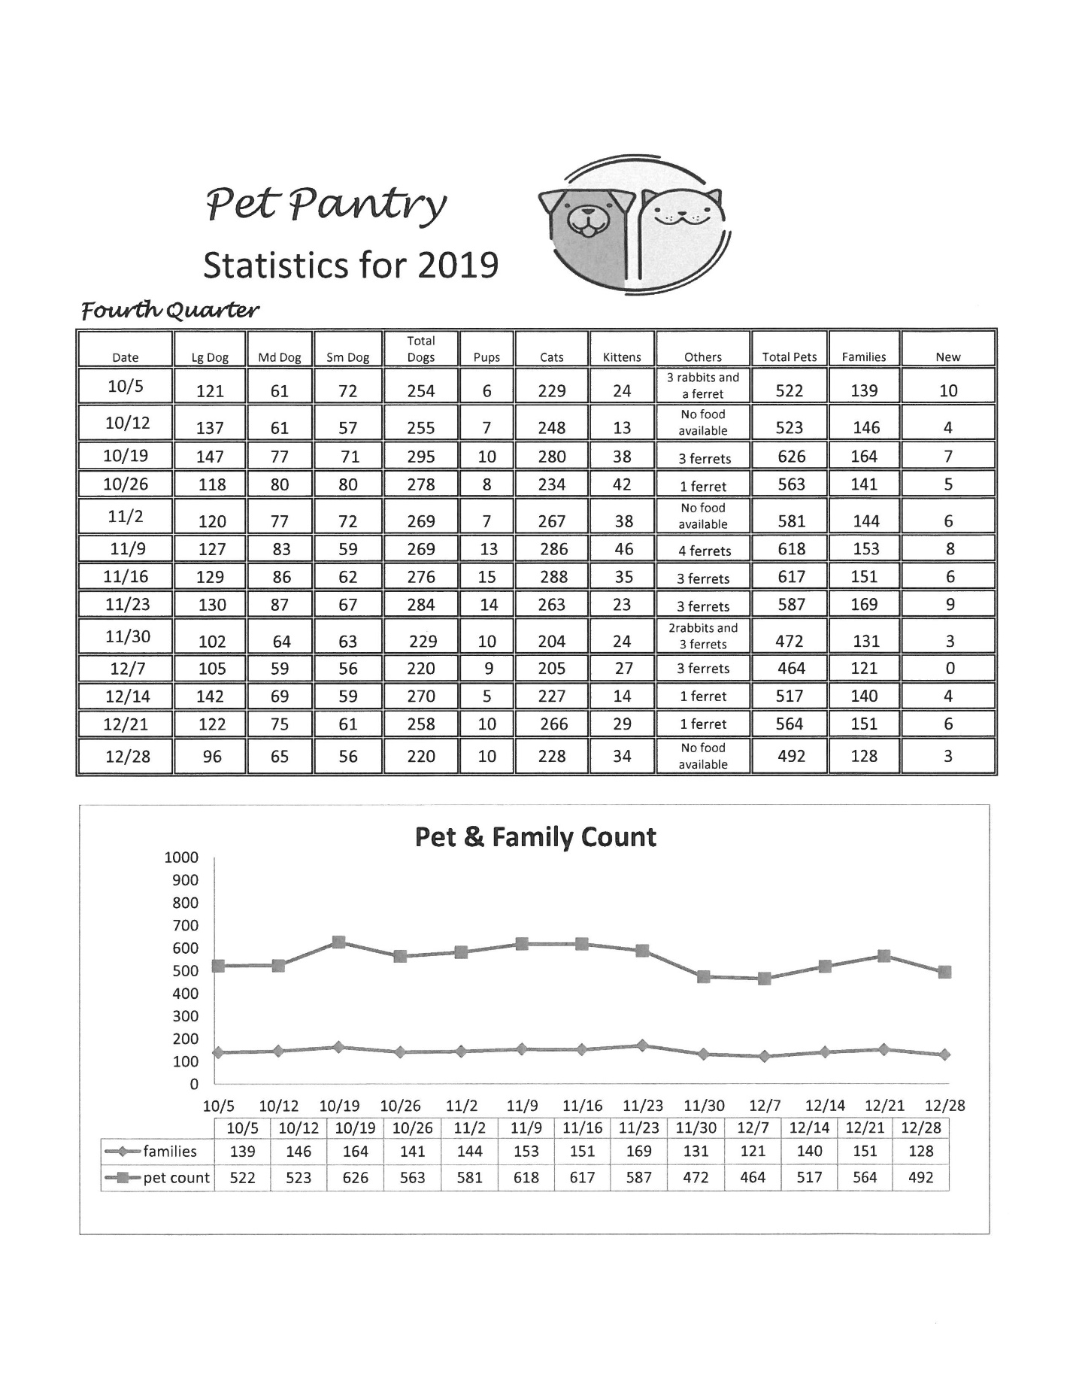

STEPHEN MINISTRY 2019

CHRIST CARING FOR PEOPLE THROUGH PEOPLE

Once again we acknowledge the gift of Stephen Ministry to our congregation. We have provided this ministry for 21 years and continue to praise God for willing Stephen Leaders and Ministers for their dedication to service to our Lord and Savior. Stephen Ministry has become an integral way in which Trinity reaches out to its members and the community to provide care giving ministry. We continue to thank God for His blessings on this ministry.

The theme of Stephen Ministry comes from the words of Jesus, “Love one another as I have loved you”. This past May, Debra Black and Charles Baars attended the Leadership Training in St Louis to become Stephen Leaders! They have been an added blessing to the other leaders, Ruth Sarna and Karen Hunt!

These Leaders and the Stephen Ministers have provided over hundreds of hours of service to their Lord over the past year. The leadership and Pastoral support of our Interim Pastors has been of utmost importance and deeply appreciated.

We have eight active Stephen Ministers currently serving in this ministry. We acknowledge the Stephen Ministers for their continued commitment and faithfulness to this ministry and to the ongoing continuing education and supervision component of Stephen Ministry. We are presently training seven new Stephen Ministers to be commissioned this spring for their service in this ministry! The current Stephen Ministers include:
Julie Holmberg Sue Reeder
Vicki Julian Carole Rehder
Carolyn Keil Ruth Shadel
Melanie King Reece Wiley

Stephen Ministry is grounded in Jesus’ command to love one another. The Stephen Minister is a lay person, man or woman, who has undergone 50 hours of training to learn skills and develop his/her God-given gifts to assist someone in need. A Stephen Minister brings Christ’s healing love to people who are experiencing a crisis or stress in their lives by providing a “listening ear”, a non-judgmental and confidential helping hand. A Stephen Minister is not there to “fix it”, but to be the care-giver NOT the cure-giver. God is the cure giver!

We thank the members of Trinity for their continued financial support and their prayers for this ministry. We consider Stephen Ministry a GIFT of love to one another!!

In HIS Service,
The Stephen Leaders

Worship and Music Committee Annual Report 2019

Members: Annielaurie Seifert (Chair), Pastor Michael Brecke, Pastor Lou Flessner, Marilyn Clark, Sandy Cooper, Leah Larson, Webb Hecker, Maggie Werth (Choir Director), Megan McCoy (Organist)W&M Committee meets approximately monthly. We welcomed the additions of Pastor Michael, Maggie, Megan, and Webb to the committee this year.Emails regarding various W&M related activities are sent to the leaders of other groups--Altar Care, Ushers, Assisting Ministers, Lectors, Acolytes, and occasionally others.
In 2019 we interviewed and hired Megan McCoy to be organist and Maggie Werth to be director of choirs. They currently are contracted to work through May 2020 with possibility (probability) of being re-hired for another year.
The organ and the pianos in the sanctuary and music room have been tuned. A humidifier is being purchased (thank you to Endowment Committee for the funding) for the music room piano.
We arranged, with Altar Care, for the wine storage to be moved from the office to the wedding closet which is closer to the sacristy for the convenience of the Altar Care volunteers.
In the spring, the Lenten mid-week services were replaced with the Refresh program reexamining our baptisms and our Lutheranism. There were approximately 40 participants each week. At Advent, the Call Committee oversaw the mid-week services with a look at our responsibilities in calling a new pastor. W&M oversaw the soup suppers. There were 15-30 participants each week.
Julie Holmberg graciously agreed to renew as Baptism Coordinator and she, Marianne Wilkinson, and Annielaurie Seifert , met to plan a Baptism Celebration on November 3 for members baptized over the past 4 years. Julie will coordinate with the pastor, the office staff, and the families to provide a loving baptismal experience.
The committee took over handling the flower ordering for Christmas and Easter flowers from HyVee, which included coordinating the change from the 6th Street store to the 23rd Street store. We are re-evaluating the quantities of flowers for Christmas and Easter.
The committee oversaw ordering Advent and Christmas decorations and decorating the sanctuary. Thank you to Carol Ann Salber for laying out the lights, to Julie Holmberg for donating stunningly beautiful ornaments, and to Brad Richardson for help with the tree, setting up the crèche, and bringing the crèche figurines to the sanctuary.
Plans for the Christmas Children’s Program were born out of the committee and Maggie worked with the Sunday School participants on it. (It was a most awesome program, by the way.)
Plans are underway to begin a neighborhood children’s choir. Sandy Cooper is in charge and a board has been established, action item list has been prepared, and action assignments have been made. It will have its own 501c3 nonprofit identity and will have its own budget (a generous donation to begin work has already been made).
Training for acolytes was held in August. Trainings for other worship assistants will be forthcoming.
Work has begun on updating or creating positions descriptions for each of the worship assisting areas. These will be finalized with cooperation from the particular groups.
We are working toward consolidating the worship supplies that are currently being stored in various closets and rooms around the building.
We will be re-lighting the eternal flame and it should make its fiery appearance at the Easter Vigil.
Plans for 2020 include
–Changing out the light bulbs in the sanctuary to warm colors and a little brighter.
–Having the back altar and the stained glass above it cleaned (currently soot-covered).
–Participating in the community Taize services.
–Recitals in the sanctuary.
Respectfully submitted,
Annielaurie Seifert

Lutheran Campus Ministry 2019 Annual Report
Mission--At the intersection of faith, service and community lies Westwood House. We are a campus ministry dedicated to combating food insecurity at the University of Kansas, Haskell Indian Nations University, and other local colleges.
Westwood House brings together two campus ministries with long histories at the University of Kansas: Wesley KU and Lutheran Campus Ministry at KU. Lutheran Campus Ministry began in the 1920s at Trinity Lutheran Church. The first Lutheran Campus Pastor was called to KU in 1962. Like Moses and the Israelites, LCM KU wandered around Lawrence, until finally reaching Westwood House in 2013. From the websites:
Westwood House is a student-led community that meets for service, worship, food, fun, and study. We are a Christian organization that welcomes the involvement, perspectives, and leadership of all people.
Students of any faith, race, ethnicity, or orientation are welcome to come, eat, and talk. We are a Reconciling in Christ community. All students are welcome, as we value diverse understandings and backgrounds. Westwood is an inclusive community that welcomes people of all faiths or no faith at all. Worship is on Wednesday evenings at 7 P.M. All people of all faiths are welcome to receive communion.
Westwood House offers free meals and a food pantry to those who are food insecure. The food pantry is open 4-7 P.M. on Sundays and Thursdays. We are conveniently located at 1421 W. 19th Street, just west of the corner of 19th and Naismith.
Free meals are offered on Wednesday, Thursday and Sunday. Wednesday nights (6 P.M.) are vegan night, where tasty and healthy meals are provided. Thursday nights (6 P.M.) are Ikigai Noodles, a fresh and delicious take on ramen. Sunday night dinners (5 P.M.) are prepared by Chef Jan Loux. Vegan, vegetarian and gluten-free options are available.
Board members are Susan Gronbeck-Tedesco (Chair, Good Shepherd), Shawn Norris (Campus Pastor), Becky Foerschler (GS), Anne Wallen, Mark Brooks (GS), Jan Loux (GS), Shantel Grace, Matthew Elliot (TLC), and Annielaurie Seifert (TLC). Ann Nichols (GS) is the financial secretary. Joanne Hickey (GS) is the program director.
The board meets approximately monthly. We could use more members from TLC.
In August 2018, Wesley KU moved into Westwood House and a joint ministry supported by the Evangelical Lutheran Church and the United Methodist Church was established. Susan Mercer is the Methodist campus minister.
2019 Activities
2019 was a year of continued growth in Lutheran Campus ministry. Weekly student participation grew to 500 students each week in various programs offered at Westwood House and on campus.

In response to this growth, two initiatives rose to the forefront of planning: 1) expansion of Westwood facilities to accommodate the regular student demand; and 2) a need for additional staff support to help manage student programming and a capital campaign to underwrite building expenses.

Two grants, a $5,000 Endowment Grant from Trinity Lutheran (Lawrence) and a $4,000 grant from Good Shepherd (St. Louis) provided assistance in establishing a new Program Director’s position and a student leadership program that provides student internships. We have a total of eight student interns who receive a small stipend for ministry work and meet regularly to learn about their gifts, leadership style and reflect on Biblical stories of call.

In addition to the regular weekly schedule of programs, services, and meals, LCM engages in special fundraising activities each month.

January Trivia Night & Silent Auction, January 25, 2019, First Lutheran, Mission Hills
February Allen Fieldhouse Clean-up, February 9, 2019
March Alternative Spring Break, Rapid City, South Dakota and the Pine Ridge and
Eagle Butte reservations.
April
May KU Commencement; End of Academic Year Activities
June/July Synod Assembly
Charting a Course for a Capital Campaign
August Move-in Day Program
Welcome to Westwood House
September Banquet/Campaign Announcement
October Year-end Fundraising Materials developed for November Initiative
November Chili Cook-off Fundraising Event
LCM Alumni Weekend
Westwood House Thanksgiving
End of Year Fundraising Appeal
December Mid-year Graduation Recognition Ceremonies

Check out the bulletin board in the TLC office hallway for pictures of student activities and a list of current offerings.
Respectfully submitted, Annielaurie Seifert

