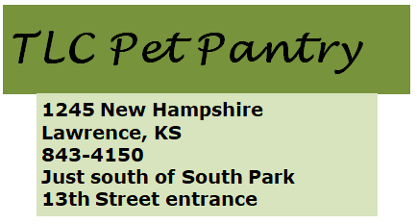in







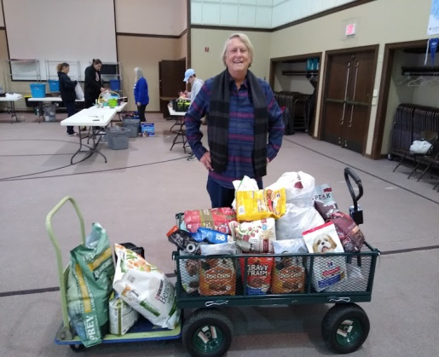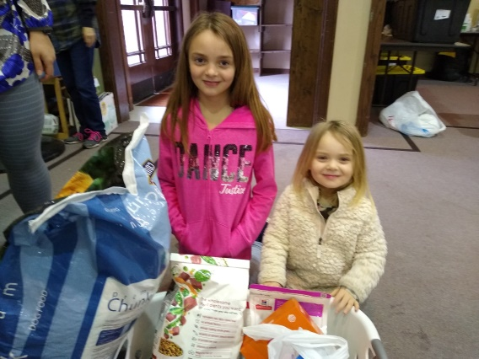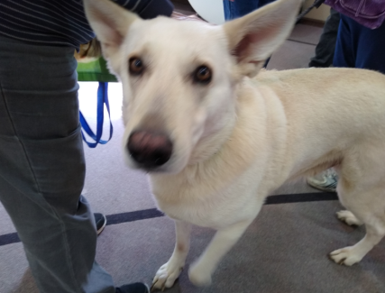

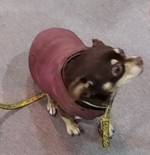

Gerald Armstrong donated a sizeable amount of dog food.

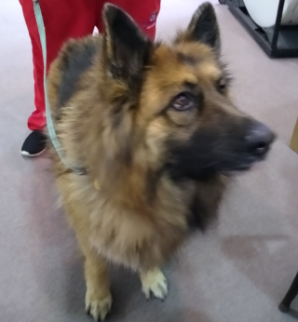

Big sister, Grace Harris asked those attending her birthday party to bring donations for Pet Pantry instead of gifts for her.

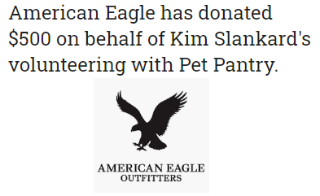

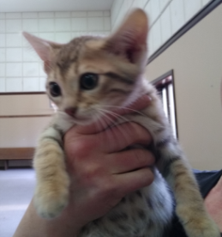





EarthWise Pet Lawrence is a family affair.  John Funk is joined in the shop

by mom and dad, Kathy and Doug.  They all strive, first and foremost, to educate pet owners

because they want the best life possible for furry family members.  John has undergone

professional training in pet nutrition and raw food feeding and earned Pet Nutrition Specialist

status.  EarthWise is a green business - they promote companies that have green practices and use

recycled materials.  Their business practices reflect their concern for preserving the environment. They work hard to make Lawrence a better community with a focus on local animal issues, and have a passion for rescued animals.  They jumped on early in their support of the Pet Pantry.

And John does magic as he grooms a doodle and a poodle.  He works wonders on his clients' coats, bringing back health and shine.  His clients' and their families love him!

Check out their website at *lawence.earthwisepet.com* for either pickup or free same or next day delivery within city limits.

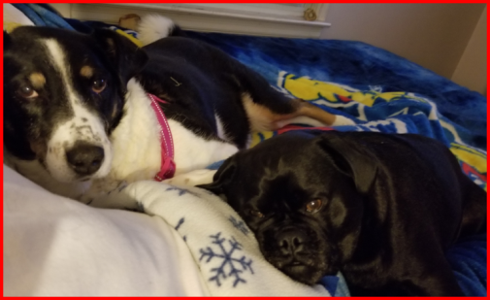

**Susan Hadl**

She shopped her idea, found enthusiastic support from church friends, and the Pet Pantry was born.  Susan has been the driving force behind the birth, growth and sustainability of the Pantry since its inception five years ago.

Susan is devoted to the Pantry mission of keeping pets with their families.  On a weekly basis, she picks up donations, buys needed food and supplies, finds and works with volunteers, organizes and sets up the Pantry for Saturday and, on Saturday, serves those using the Pantry.  She assists in fund raising, and chairs and guides the advisory team that determines Pantry policies and procedures.

We, and the pets and families we serve, are grateful for Susan's insight, dogged determination and her love of animals.  We used to think she went home to a quiet home. As the photos reflect, her home is full of life and love!

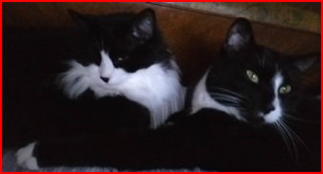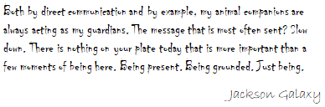

L to R; Sammy & Hans

L to R; Franniemax & Luther

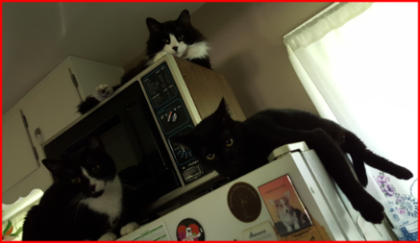



L to R; Luther, Franniemax & Mr. Lee

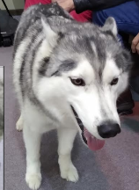

**In loving memory of one of the biggest Pet Pantry fans and our mascot Allie Gray**

Jill Robinson



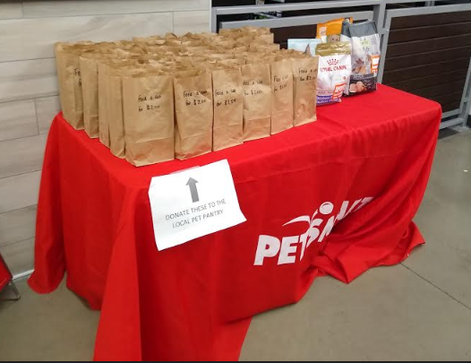

Petsmart conducted a food drive for Pet Pantry during the last part of February



